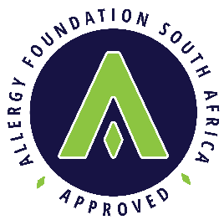

Application to use the Allergy Foundation Seal of Approval

Contact Details

Name
Street Address
Postal Address
Telephone number
Cell phone number
Email address

Business Information

Name of company – full registered name (if not an individual application)
Partnership – full names of partners (if applicable)

Trade name of business
VAT number (if applicable)
Company registration number
Website address

Details of Product

Brand name
Brief description of product/s

Please state where the product/s can be purchased? Shops and Online
What website address would you like us to link your product/s to?
Please state the date from which you would like product to bear the Seal of Approval
Have you applied for any endorsements or Seals of Approval for this product?
If yes, please provide details
Do you have product testing reports for your product? If yes, please provide report
Which allergens would you like your product to be tested for? The laboratory will privately invoice you direct for tests

Declaration

I/ We hereby apply to use the Allergy Foundation Seal of Approval on the above mentioned commodity. The AFSA Seal of Approval confirms that the products have been scientifically tested to show that they are efficient at reducing or removing allergens from the environment or that they have significantly reduced allergen or chemical content. In order to receive the Seal of Approval, manufacturers have supplied verifiable results of independent testing or testing has carried out via AFSA by independent laboratories to standards created for the Seal of Approval by leading allergy specialists. Due to patient variation, however, use of these products cannot be guaranteed to reduce symptoms in allergic sufferers.

Should approval be granted, I/We observe to undertake the requirements of the Allergy Foundation South Africa’s Allergy Seal of Approval certification of 1 January 2017.

Print Name Signature Designation
Signed at ______________ of this ______________ day of _____________ 26

Allergy Foundation of South Africa is the operational name of the South African Allergy and Clinical Immunology Foundation, a non-profit company registered in South Africa.NPC No. 20151249989108

